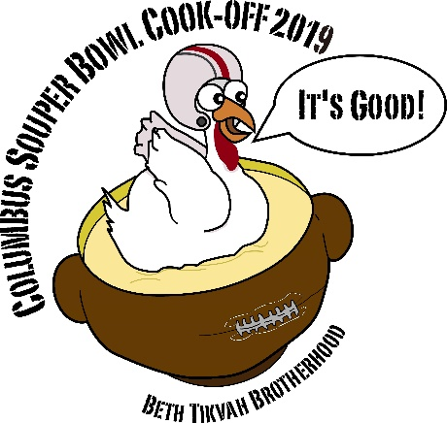 | Amateur Entry Form  COLUMBUS SOUPER BOWL XIII  SATURDAY, February 2, 2019  Congregation Beth Tikvah  6121 Olentangy River Road, Worthington, OH 43085

- Soup entree space provided – Please feel free to decorate space
- Heat for soup provided (if not needed , check here ___ )
- Entrant identification sign provided
- Awards:
$50 - Gift Certificate to each Soup Winner: Chicken Soup & Non-Chicken Soup

Please check a category / type of soup you will compete in:
Chicken Soup _____

Non-Chicken Soup _____
(Non-chicken soup includes vegetarian, beef, gluten-free, etc.)

Name of entrant: __________________________________________________
Contact: _________________________________________________________
Address: ________________________________________________________
Phone: ______________________ Email: _____________________________

Amateur entrant: $25.00 fee per soup entry - minimum of 3 gallons of soup needed per entry. (Please, no pork products or shellfish. Copies of recipes appreciated.)
Set-up begins after 3:00 PM. Cook-off tasting from 5:00 – 7:00 PM.

Entry fees must be received by December 31, 2018.

Please make checks payable to The Beth Tikvah Brotherhood

Received by: ______________________________ Date: _______________
(Brotherhood member)
~ Or ~

Mail to: Congregation Beth Tikvah Brotherhood
6121 Olentangy River Road, Worthington, OH 43085

